1. **#git status**

**To check status of script/files present in git repo.**

1. **#git add filename**

**To track untracked file. Post add git will start tracking that file.**

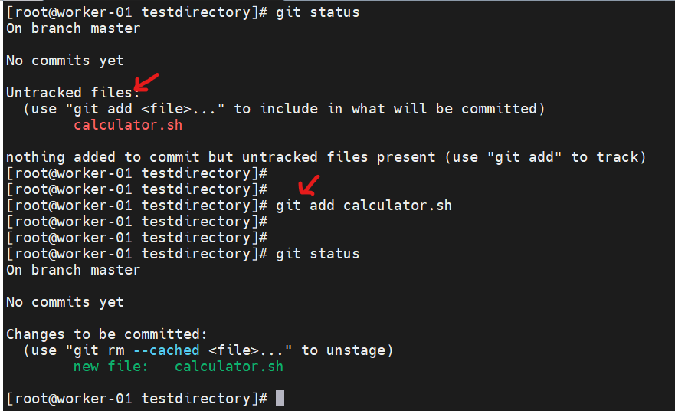

1. **If you made changes in tracked file and did not commit it then it will show in git status.**

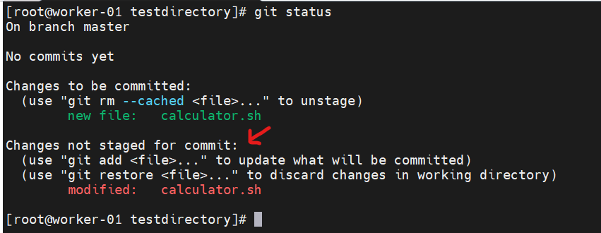

1. **#git diff**

**To check what changes done in tracked file.**

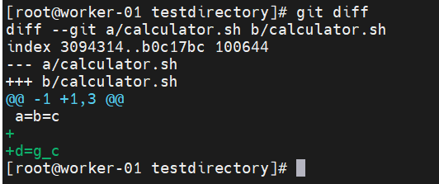

1. **#git commit -m “this is first version of calculator script”**

**To commit the changes post modification of tracked file.**

**Note: Before committing you need to track that file again.**

**So, steps will be as follow,**

**#git add calculator.sh**

**#git commit -m “this is first version of calculator script”**

1. **#git log**

**To check your committed history details**

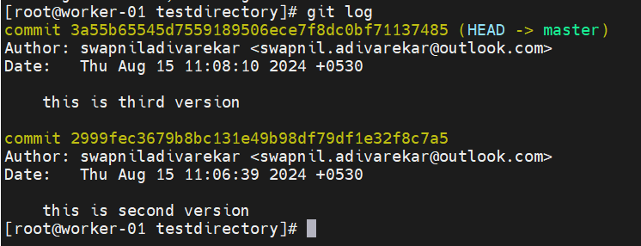

1. **#git reset --hard 2999fec3679b8bc131e49b98df79df1e32f8c7a5**

**To restore the old copy.**

